Software Engineering Project
Needs Statement

Purpose

The Source Code Visualizer aims to improve code comprehension and navigation by transforming complex source code file into a clear and structured diagram. This makes it easier to identify key components in the code, ultimately supporting faster debugging and maintenance.

The Source Code Visualizer Functional Need Statement

The source code visualizer is a tool that loads existing source code, analyzes its structure, and generates a visual representation of its elements such as classes, functions, and their relationships.

- Source code visualizer functions

  - Load an existing program written in python to analyze its structure.
  - Analyze the programs code to identify classes, functions, loops, and branching points.
  - Generate a visual representation of the programs structure.

- Visualization Generation
  - A diagram is created with nodes that represent classes and functions.
  - Nodes are connected to show how the source code is connected.
  - Diagrams can be exported as various formats including pdf and Jpeg.

- Documentation and Testing
  - The Source Code Visualizers user manual details how to install, load source code, and create diagrams.
  - Test results will demonstrate that the visualizer correctly identifies classes and functions and properly displays their relationships and dependencies.

Use Case Diagram

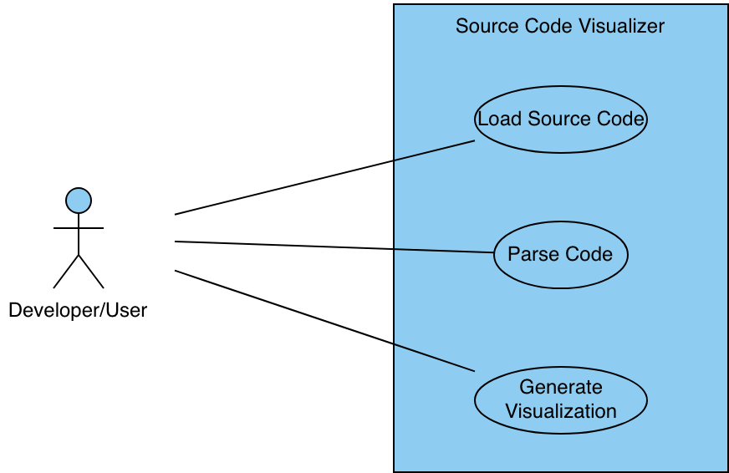

Use Cases

Use Case 1: Load Source Code
Actor: Developer/User
Goal: User wants to load a source code file into the visualizer to prepare it for analysis
Actor Actions | System Responses
- User selects Load File | - File browser opens
- Source code is selected | - File is loaded

Use Case 2: Parse Source Code
Actor: Developer/User
Goal: User wants the system to analyze the loaded code to extract structures and relationships
Actor Actions | System Responses
- User clicks parse code | - System reads source code
 | - System identifies classes, functions, and their relationships

Use Case 3: Generate Visualization
Actor: Developer/User
Goal: User wants to see a visual representation of the source code structure
Actor Actions | System Responses
- User selects Show Diagram | - System retrieves parsed code
 | - System generates diagram of nodes with connections showing relationships
- User can export the diagram

Risk Diagram

